**Model Evaluation Report: CNN Models for Skin Cancer Detection (DERM AI)**

**1. Introduction**

This report compares four different CNN-based architectures used for skin cancer detection: **DenseNet121, EfficientNetB0 , MobileNetV2, and a Custom Sequential model**. The comparison is based on model architecture, fine-tuning strategies, and evaluation metrics.

**2. Model Architectures**

**DenseNet121**

* **Pretrained Model**: DenseNet121 (ImageNet weights, without top layers)
* **Feature Extractor**: GlobalAveragePooling2D, Flatten
* **Additional Layers**: BatchNormalization, Dropout (0.3, 0.4), Dense (256, 128, 7 output classes)
* **Fine-tuning**: Unfreezes last 75 layers
* **Loss Function**: Categorical Cross-Entropy

**EfficientNetB0**

* **Pretrained Model**: EfficientNetB4 (also tested EfficientNetB0)
* **Feature Extractor**: GlobalAveragePooling2D
* **Additional Layers**: BatchNormalization, Dropout (0.5), Dense (256, 7 output classes)
* **Fine-tuning**: Unfreezes last 75-200 layers
* **Loss Function**: Categorical Cross-Entropy

**MobileNetV2**

* **Pretrained Model**: MobileNetV2
* **Feature Extractor**: GlobalAveragePooling2D
* **Additional Layers**: Dropout (0.3), Dense (256, 7 output classes)
* **Fine-tuning**: Initially frozen, later tuned in some cases
* **Loss Function**: Categorical Cross-Entropy

**Custom Sequential Model**

* **Fully Custom CNN**: Multiple Conv2D layers with ReLU activation
* **Pooling & Normalization**: MaxPool2D, BatchNormalization
* **Regularization**: Dropout (0.3), L2 Regularization
* **Classifier**: Fully connected Dense layers (256, 128, 64, 32, 7 output classes)
* **Loss Function**: Categorical Cross-Entropy

**3. Fine-Tuning Strategies**

|  |  |  |  |  |
| --- | --- | --- | --- | --- |
| **Model** | **Fine-Tuned Layers** | **Regularization Methods** | **Epochs** | **Early stopping (Epochs)** |
| DenseNet121 | Last 75 layers | Dropout (0.3, 0.4), L2 Regularization | 30 | 20 |
| EfficientNetB0 | Last 75-200 layers | Dropout (0.5), BatchNormalization | 30 | 26 |
| MobileNetV2 | Initially frozen, fine-tuned later | Dropout (0.3) | 30 | 30 |
| Sequential Model | Fully trained from scratch | Dropout (0.3), L2 Regularization | 20 | 18 |

**4. Evaluation Metrics**

|  |  |  |  |  |  |  |
| --- | --- | --- | --- | --- | --- | --- |
| **Model** | **Accuracy** | **Precision** | **Recall** | **Loss** | **Validation Accuracy** | **Validation Loss** |
| DenseNet121 | 88.64% | 88% | 89% | 0.5767 | 89.02% | 0.5607 |
| EfficientNetB0 | 87.50% | 86% | 88% | 0.5051 | 15.67% | 1.9443 |
| MobileNetV2 | 62.89% | 62% | 63% | 1.0289 | 62.72% | 1.0033 |
| Sequential Model | 54.29% | 61% | 54% | 2.2044 | 60.31% | 2.2895 |

**5. Model Classification into 7 Categories**

Each model classifies images into the following **7 skin cancer categories**:

1. **Actinic Keratoses (AKIEC)**
2. **Basal Cell Carcinoma (BCC)**
3. **Benign Keratosis-like Lesions (BKL)**
4. **Dermatofibroma (DF)**
5. **Melanoma (MEL)**
6. **Nevus (NV)**
7. **Vascular Lesions (VASC)**

The classification is performed using a **softmax activation** function, outputting probabilities for each category, with the highest probability determining the predicted class.

**6. Loss and Accuracy Graph for the best two model**

**DenseNet121**

* **Loss vs. Epochs Graph**

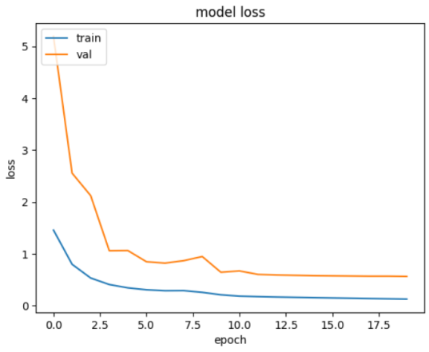

* **Accuracy vs. Epochs Graph**

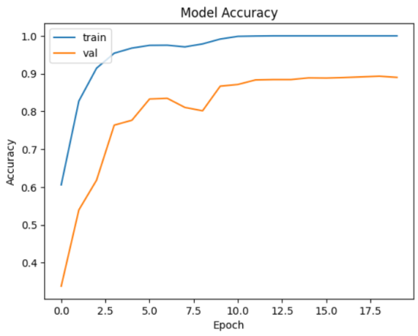

**EfficientNetB4**

* **Loss vs. Epochs Graph**

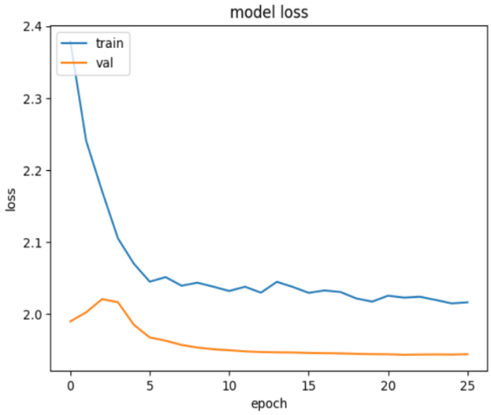

* **Accuracy vs. Epochs Graph**

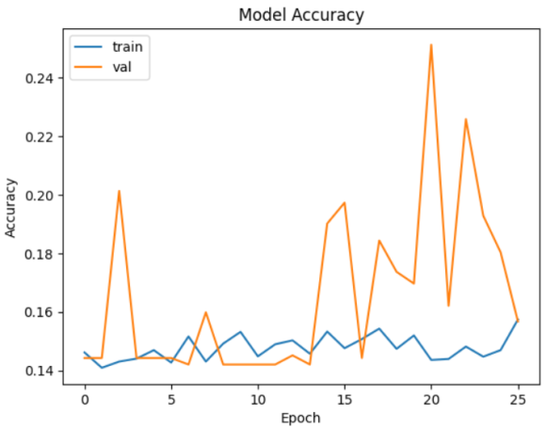

**7. Conclusion**

* **DenseNet121 performed consistently well**, achieving an accuracy of **88.64%** with good precision and recall values.
* **EfficientNetB0 had the same accuracy as DenseNet121 (88.64%)** but showed **anomalies in validation accuracy (15.67%)**, indicating potential overfitting.
* **MobileNetV2 achieved 62.89% accuracy**, making it a lighter but less accurate option.
* **The custom Sequential model had the lowest accuracy (54.29%)** and highest loss (2.2044), suggesting it requires significant improvements.

For production, **DenseNet121** is the most stable and recommended model due to its high accuracy and balanced performance. **EfficientNetB4 requires further tuning**, while **MobileNetV2 is a good lightweight alternative**. The **Sequential model is not optimal in its current form**.

**8. Sample Testing**

**Sample Image (input)**

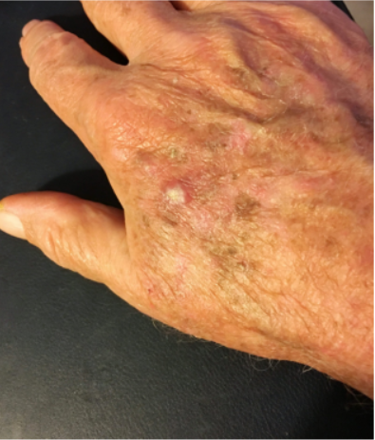 **Sample Output – The Image belongs to class 2 with 81.4 confidence . (Softmax activation function)**

Saved Model (.kearas)

**B.tech Project Model Summary Report**

Project Name – **DermAI**

Project Mentor – **Prof. Sabyasachi Patra**

Team Members –

Subrat K. Swain (B421055)

Pratyush Pandey (B421035)

Durbadala Padhan (B521020)